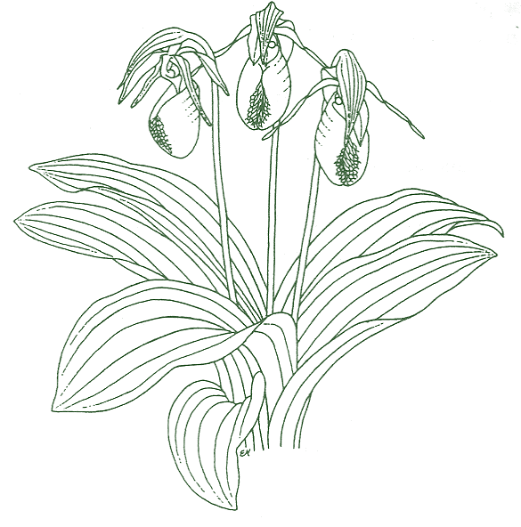 | North Carolina Native Plant Society
Native Plant Habitat Certification Application

Name: |  | Current Member?

Street Address:
City/Zip Code: |  |  | County:
Email: |  |  | Preferred Phone:
Date of Application:
Name(s) and address to appear on certificate:

ABOUT YOUR PROPERTY
Total property size:
Approximate percentage of that area dedicated to North Carolina native plants:
Number of years you have been working on creating native habitat on your property:

LANDSCAPE PROFILE

Terrain: |  | Level ground |  | Gentle slope |  | Steep slope
Exposure: |  | Primarily sunny |  | Mixed sun/shade |  | Primarily shaded

LANDSCAPE FEATURES (check all that are applicable to your garden/yard):

 | Wooded area |  | Native grass lawn |  | Meadow/prairie |  |  | Pond/lake
 | Rock retaining wall |  | Rock outcropping |  | Rock garden |  |  | Stream/creek
 | Pollinator garden |  | Sitting/viewing area |  | Garden path |  |  | Rain garden
 | Arbor |  | Moss garden |  | Other:

Interesting historic features of your property (if applicable):

NATIVE PLANTS ON YOUR PROPERTY
For NCNPS certification, a native garden must have representation in a minimum of 5 of the 11 plant categories listed below. Plants listed should be native to North Carolina. List both scientific and common names on this application. As noted in the Introduction, HELP is available if needed!

CATEGORIES

1. Canopy Trees (3 species minimum):

2. Understory Trees (3 species minimum):

3. Shrubs (3 species minimum):

4. Herbaceous Flowering Plants: (annuals, biennials, perennials): Spring-blooming (3 species minimum):

5. Herbaceous Flowering Plants: (annuals, biennials, perennials): Summer-blooming (3 species minimum):

6. Herbaceous Flowering Plants: (annuals, biennials, perennials): Fall-blooming (3 species minimum):

7. Ferns (3 species minimum):

8. Grasses (3 species minimum):

9. Vines: Herbaceous or Woody (3 species minimum):

10. Mosses & Lichens (3 species minimum):

11. Water/Bog (3 species minimum):

REMOVING INVASIVE PLANTS FROM YOUR LANDSCAPE

Invasive plants are non-native plants that spread aggressively and displace the native plants upon which insects and other wildlife depend for food. They create food deserts, overwhelm natural areas, and destroy trees. For NCNPS certification, a native garden/landscape should be as free as possible of non-native, invasive species. (Refer to the NCNPS Invasive Plant List noting the invasive species of greatest concern are Ranks 1 & 2.) Please list the invasive, non-native plants found on your property. Which ones have you removed, are attempting to remove, and/or are preventing from reproducing by seed from your property:

CONSERVATION PRACTICES

At least 6 of the following conservation practices are required for certification. Please check those that apply.

Avoid chemical use where possible
Control pests naturally by encouraging beneficial insects - No broad-spectrum insecticides
Minimize or eliminate lawn areas
Allow leaves to remain where they fall
Capture and utilize rainwater
Compost plant material, such as grass clippings and vegetable peels, in a bin or pile
Install native plants facing destruction, obtained through organized rescues. Check with your local chapter for rescue events
Provide water sources for habitat support such as water features, bird bath
Use groundcover, leaves or hardwood mulch to retain moisture
Use soaker hoses or hand watering rather than overhead sprinkling
Leave older and non-hazardous dead trees in the landscape
Guard against human-made hazards including window collisions, light pollution, don’t use poisonous or glue pest traps, or plastic netting
Reduce use of yard maintenance equipment, such as fossil fuel powered mowers & blowers

WILDLIFE OBSERVED

What wildlife species do you see benefiting from your conservation gardening efforts?

SUBMITTING YOUR CERTIFICATION APPLICATION

Please feel free to use additional sheets, if necessary, to list your native plants.
Please email your application (to pat.holder@icloud.com) with at least 5 digital pictures of your garden as attachments. These pictures should show the scope of the garden as well as any special features.

Submission of this form gives the NCNPS permission to use these photos in exhibits, on the NCNPS website, in publicity materials, and in other ways that fulfill the mission of NCNPS. Credit will be given to the person who submitted the application unless another photographer is identified by the applicant.

Are you willing to allow planned visits to your garden? |  | YES |  | NO

Please enclose with your certification program application, a fee of $10 (for NCNPS members) or $35 (for non-members, includes a 1-year membership), or $45 which includes a 1-year Family Membership. Make checks payable to NCNPS. If you are not a member, we encourage you to join us; please visit ncwildflower.org/ncnps. If you represent an organization or business, please go on the website and join NC NPS under the Businesses and Organizations category. You will pay the $50 membership fee and the $10 certification application fee. Then you will receive your certification.

To share your native habitat garden/yard and the benefits of native plants, we encourage you to purchase and display our metal Certified Native Plant Habitat sign.
Would you like to purchase a Certified Habitat sign for your garden? |  | YES |  | NO
Payment for your sign will be requested once your garden has been certified.

Thank you for becoming a NCNPS certified property!
NCNPS Native Plant Habitat Certification Committee

Please email or mail your completed application to:
Email pat.holder@icloud.com
Pat Holder, Native Plant Habitat Certification Coordinator
PO Box 4895, Asheboro, NC 27204

